Year 4 Maths Home Learning Pack

Monday | Complete pages 2 - 6
Tuesday | Complete pages 7 - 9
Wednesday | Complete pages 10 - 11
Thursday | Complete pages 12 - 14
Friday | Complete pages 15 - 16

L.O – Count in multiples of 6, 7 , 9 , 25, 1000.

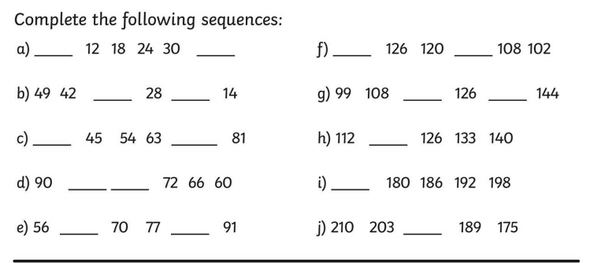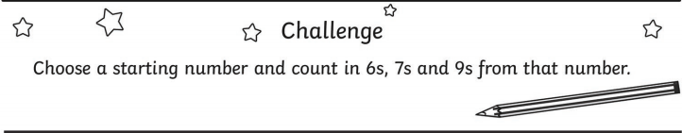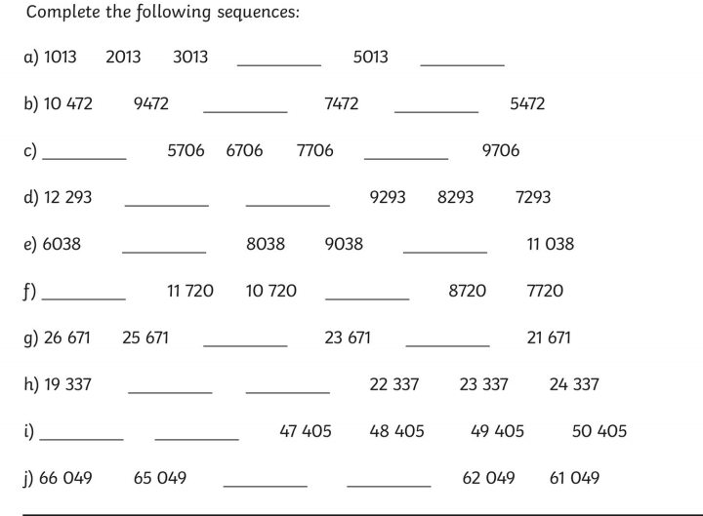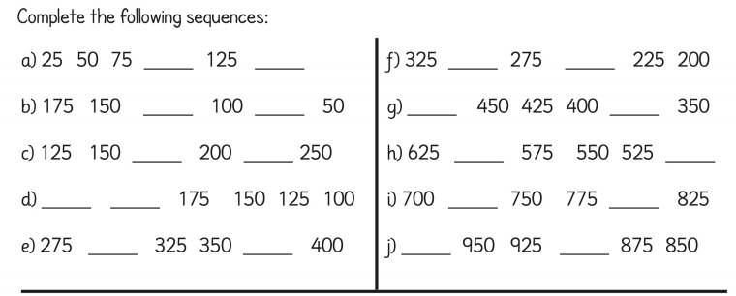

L.O – Order and compare numbers.

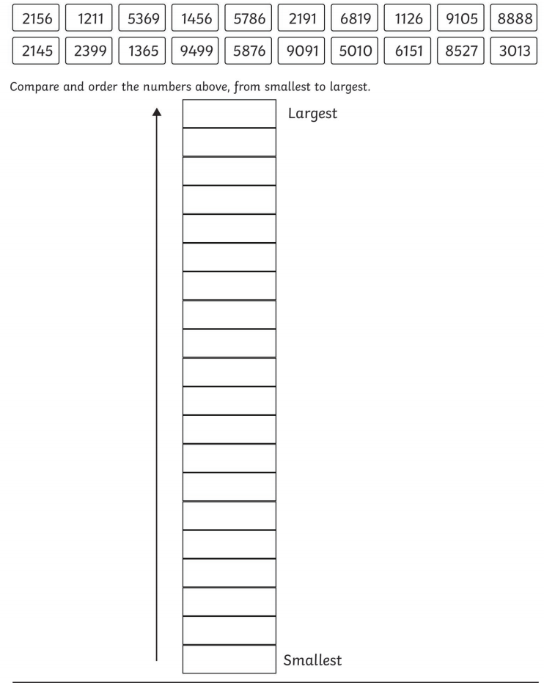
L.O– Using place Value

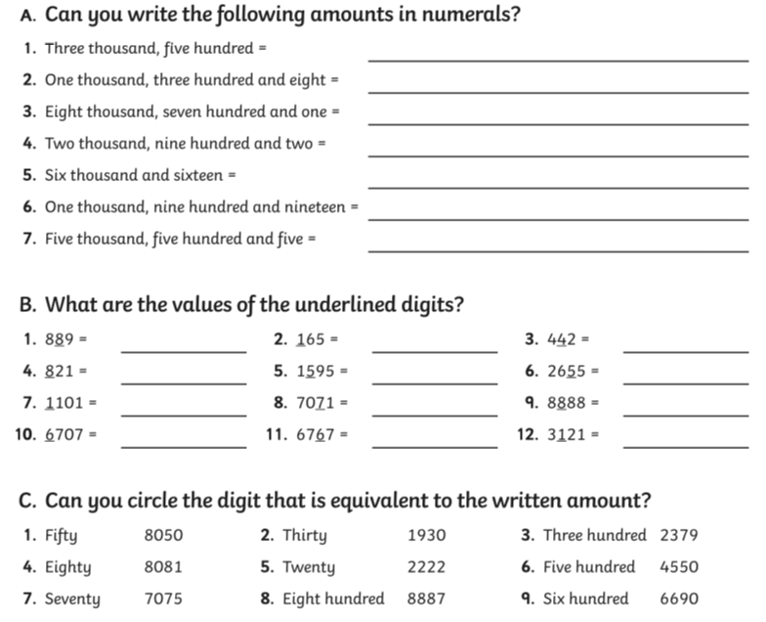

L.O –TBAT solve word problems.

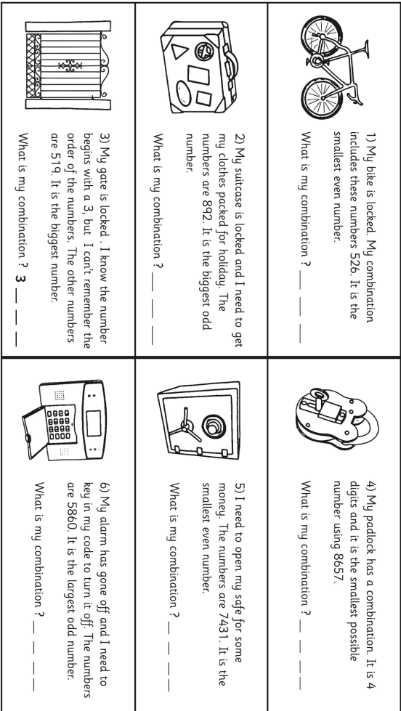
L.O –Challenge

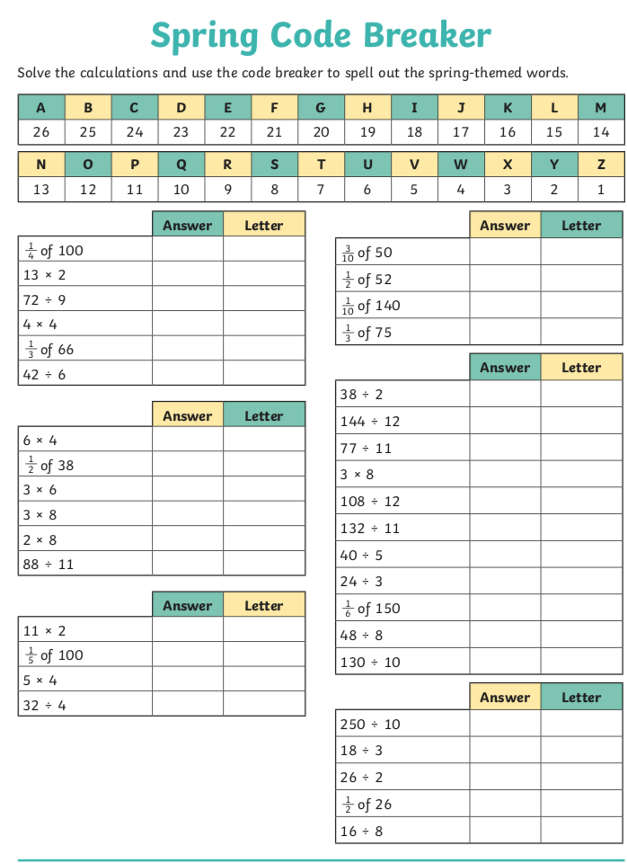

L.O – Adding using column methods.

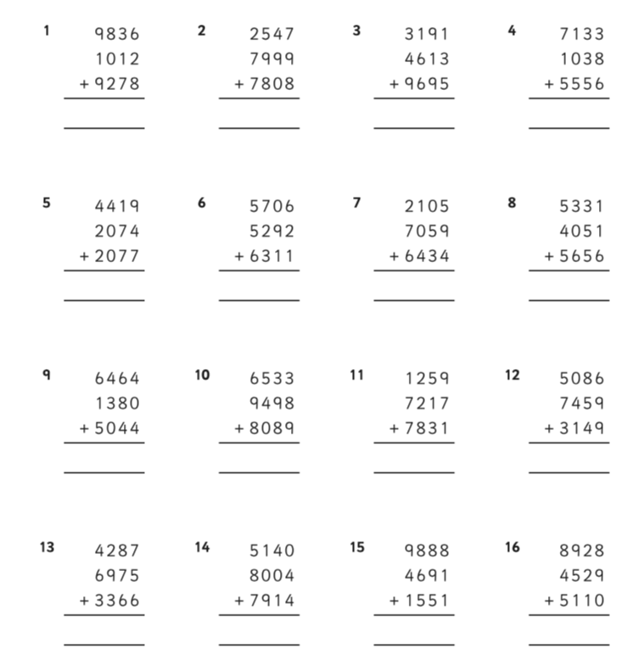
L.O –Subtracting using column method.

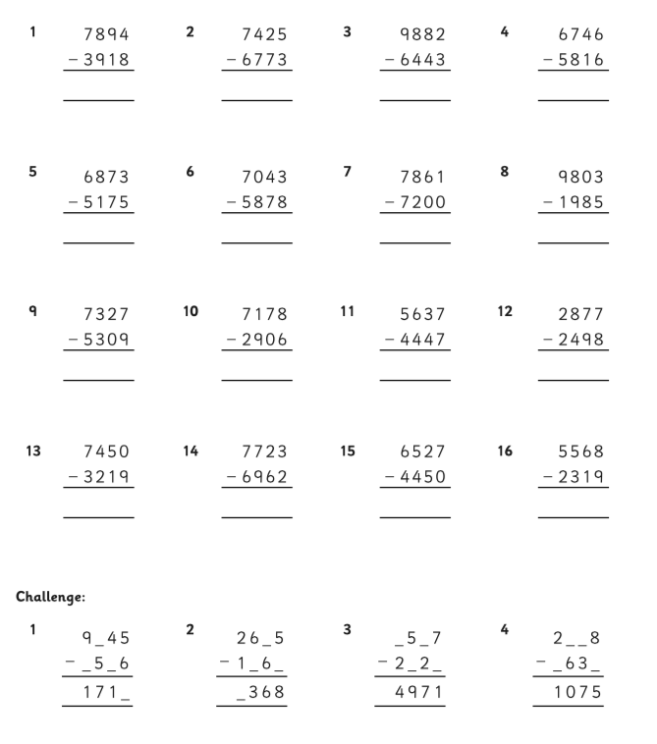
L.O –Solving problems

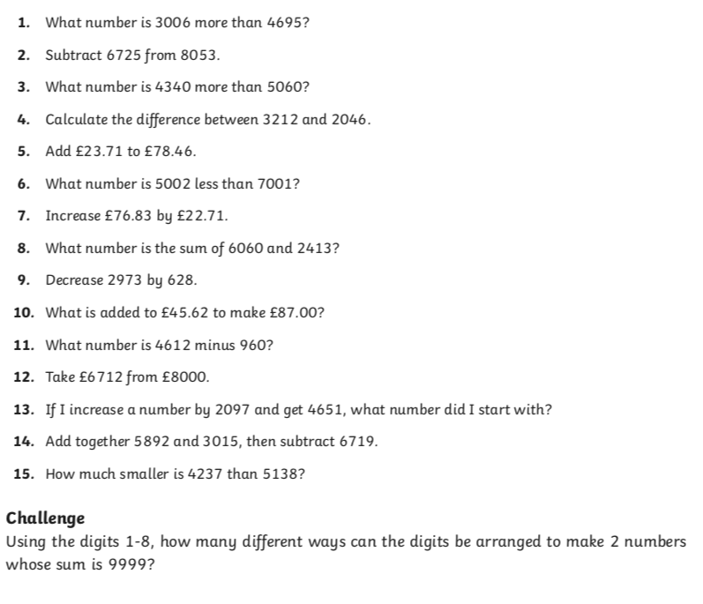
L.O – Using commutativity.

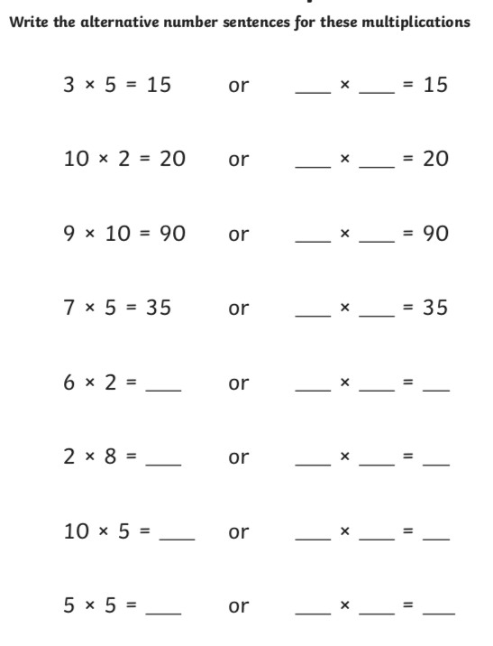

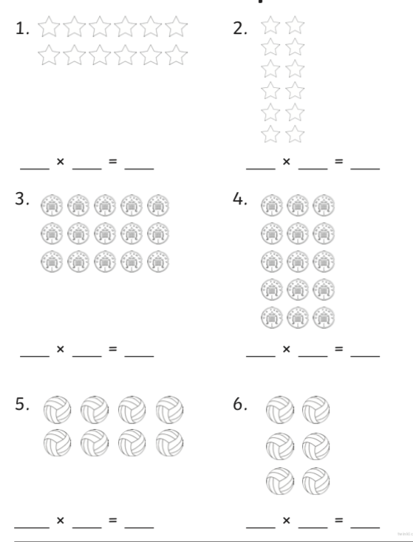

L.O TBAT multiply 2-digits by 1 digit.

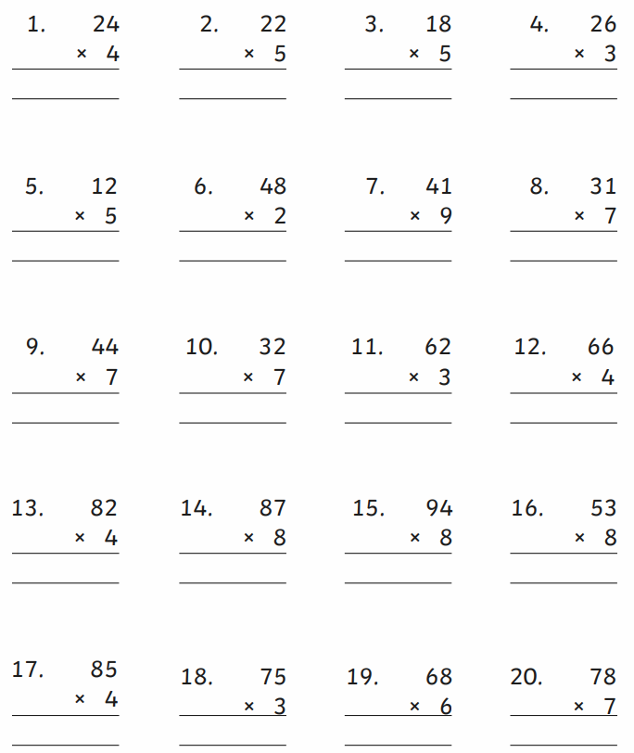
L.O – TBAT interpret data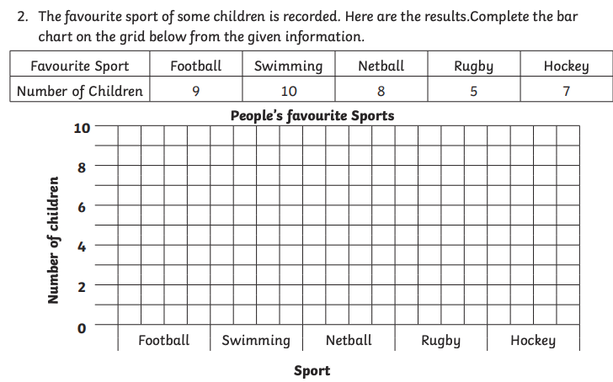

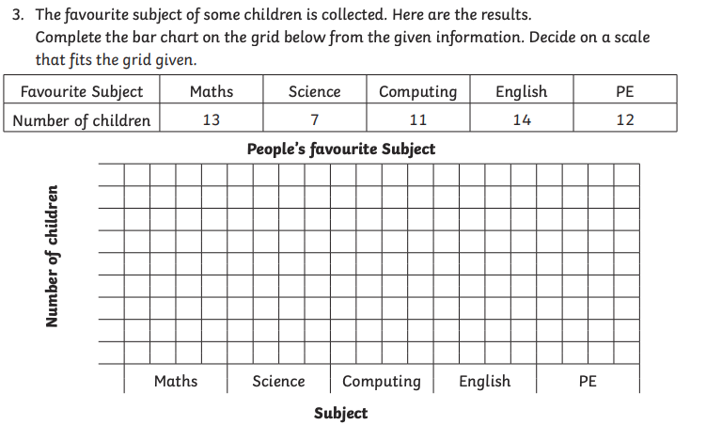

L.O –Identifying angles.

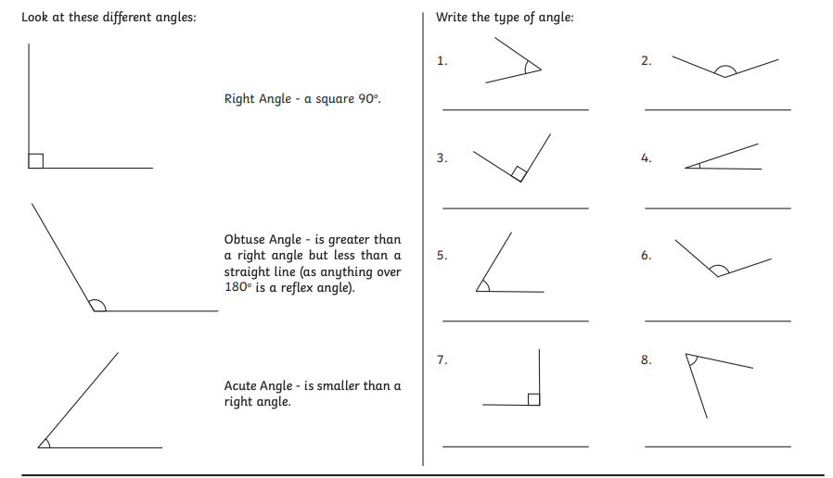

L.O –TBAT tell the time

